

Themed Days and Weeks
Autumn Term

Over the course of the year we highlight different aspects of learning and celebrate our school ethos and mission statement by giving a special focus to a particular theme.

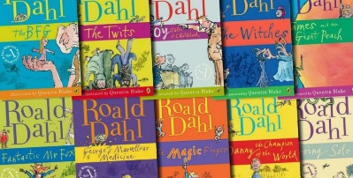
Roald Dahl Day : September
Roald Dahl day is fun filled day, aimed at encouraging the children to develop their love of books. During the day, literacy lessons will come alive with fun, book related activities to promote reading for pleasure. The culmination of our week will be a whole school assembly, during which the children will share the wonderful work that they have produced.

European Languages Day: September
Each class will study the language and culture of a different European country. The children will learn to count, the names of colours and basic greetings.
They will also learn about the culture and traditions of the country they study.

Harvest Festival : September
This year the theme for Harvest Festival will be “Fair Trade” and how this organisation supports farmers growing cocoa in Sierra Leonne.

No Pens Wednesday: October

Today the focus will be spoken language. Every activity carried out in school will involve speaking and listening to develop sharp communication skills. The children will complete problem solving activities in maths and learn to work in groups, discussing their ideas and solutions. English activities will link with National poetry day and each class will learn a performance poem by heart. They will add expression and appropriate actions and
perform it for the whole school during assembly. In topic the children will discuss and debate to deepen their understanding and strengthen their communication skills.
Anti-Bullying Week: November
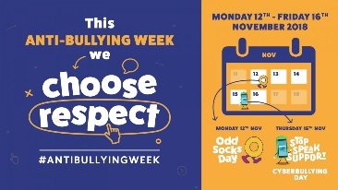
Daily assemblies this week will link to the anti-bullying theme of Respect. Each class will learn the importance of respect and how this links to their class charter. They will reflect on what a respectful school or playground looks like and how we can work together to achieve this.


Enterprise Week: November
Enterprise week enables the children to get creative; Linking with DT, the children design and make desirable products to sell at the Christmas fair. Each class produces something different, focussing on a range of DT and enterprise skills, to compete to see which class raises the most profit. Which class will it be this year?


World Children’s Day: November
Children’s Rights are at the fore front of the day. The children will be reminded of the UN convention rights of the child and they will hear inspirational stories from around the world.


Christmas Celebrations December

We always look forward to our Christmas celebrations at St Oswald’s and we make this time as special as we can for the children.
The children will all visit church for “Experience Christmas” where they are reminded of the true meaning of this special time of year.
The Christmas performance this year will be “The Wizard of OZ”.

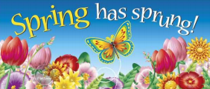

Themed Days and Weeks
Spring Term


Chinese Week February
The whole school celebrates the festival of Chinese New Year through a range of different activities and curriculum areas. We learn about Chinese culture and traditions and we even get to sample a selection of Chinese cuisines made in our very own kitchen. We encourage you to attend the Chinese New Year Celebrations that are held in Chinatown in Liverpool city centre too.

World Book Day March
We all go Book Crazy in a whole school celebration of authors, illustrators, books and (most importantly) reading. Everyone gets dressed up as their favourite book character and of course every child receives a token for a free book. This years selection includes:


British Science Week March

This year, we will celebrate Science week from 10th to 19th March. During science week the children will research famous scientists to develop a greater understanding of the contribution they have made. There will be practical Science activities every afternoon, we will even be sending a simple science investigation home for homework! A poster competition will take place too: design a science poster around the theme of "Connections" and the best five from school will be entered into a national competition. Visit www.britishscienceweek.org/plan-your- activities/poster-competition for more details.

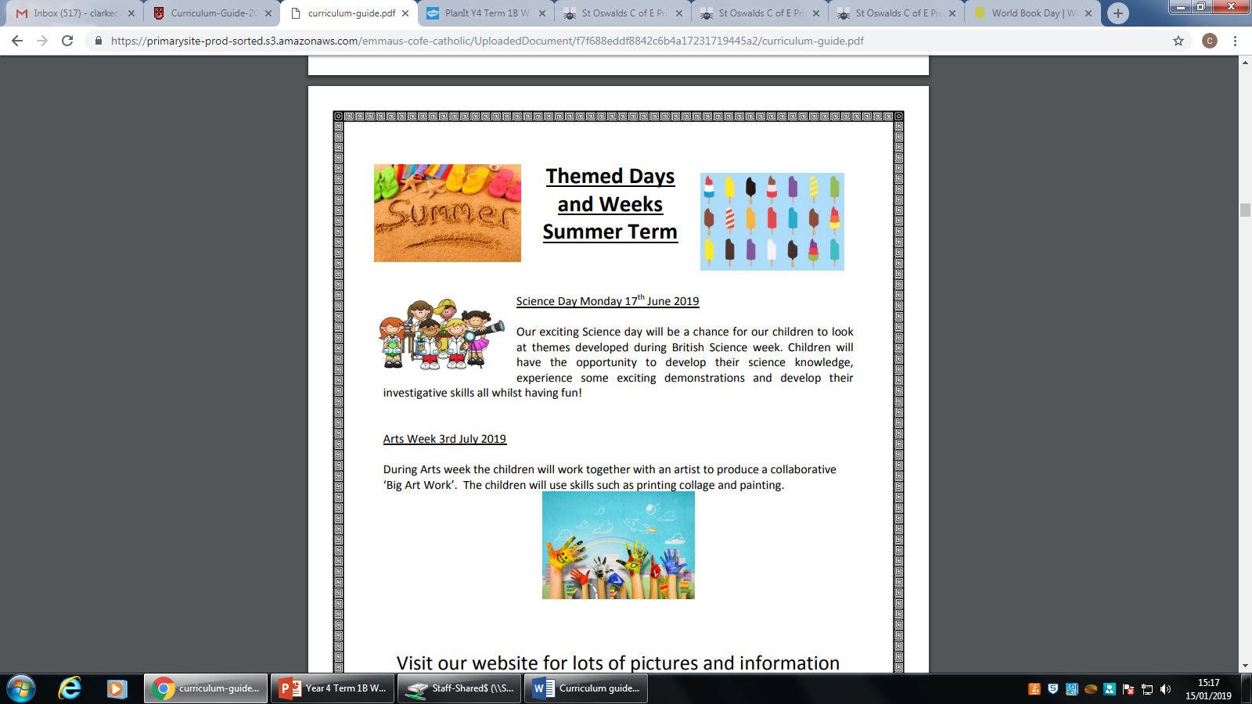
Themed Days and Weeks
Summer Term


Christian Aid Week: May
Christian Aid Week is a time when people come together from all walks of life to step out in support of the world's poorest communities. We support this by holding daily assemblies linked to this year’s theme as well as themed lessons in class. Making the children aware of global issues and the struggles that some people in our world face, develops the children’s empathy and understanding and will encourage them to take responsibility for our global community.


UNICEF Day for Change: May
Working together with UNICEF to campaign for a safer world for all our children. Classes will debate the issues raised, giving excellent opportunities to develop speaking and listening skills and writing.

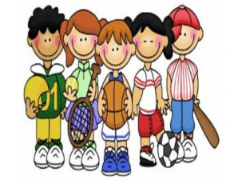
Sports Activities
At St Oswald’s we hold a range of different sporting activities across a two week period (weather permitting!!). These events help to develop the children’s sporting ability and to learn important lessons about teamwork and competition. They also provide an opportunity for them to try sports and activities that may be new to them.

Arts Week
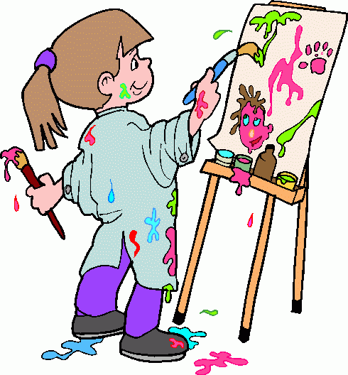
One of our favourite weeks of the year, Art Week. The children will enjoy a range of activities in class this week all based on different art forms. They will experiment with different media and ultimately work together to produce a whole class sculpture which you can come and view during our sculpture trail evening.

