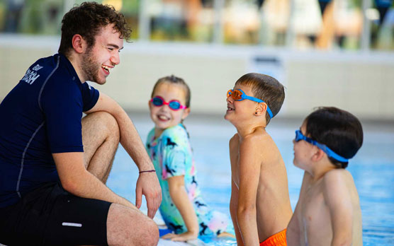**Swim Academy Open Day**

**WHAT?**

Come and try our children’s swimming lessons and baby lessons for **FREE!**

**WHEN?**

Sunday 2nd March, 9am-11am

**WHERE?**

Total Fitness, Aintree, L30 7PT

**WHO?**

Children and babies aged **0-11 years old.**

**Book a time slot!**

[**hannah.thomas@totalfitness.co.uk**](mailto:hannah.thomas@totalfitness.co.uk)

[0151 527 3600](https://www.google.com/search?q=aintree+total+fitness&rlz=1C1GCEA_enGB1131GB1131&oq=aintree+total+fitnes&gs_lcrp=EgZjaHJvbWUqCggAEAAY4wIYgAQyCggAEAAY4wIYgAQyDQgBEC4YrwEYxwEYgAQyBggCEEUYOTIICAMQABgWGB4yCAgEEAAYFhgeMgYIBRBFGDwyBggGEEUYPDIGCAcQRRg80gEINDI2NWowajSoAgCwAgE&sourceid=chrome&ie=UTF-8)