**Design Our St. Oswald’s C of E Primary School Online Safety Mascot!**

**Safer Internet Day: Tuesday 11th February 2025**

Our school is celebrating **Safer Internet Day** with an exciting challenge! We need YOU to design a creative and fun **Online Safety Mascot** that will help remind everyone how to stay safe online.

**What You Need to Do:**

1. **Think about online safety:**
   * How can your mascot teach others to stay safe online?
   * What might your mascot say or do to help?
2. **Be creative:**
   * Draw your mascot on a piece of A4/A3 paper or card.
   * Use lots of colour and make your design eye-catching!
3. **Give your mascot a name** that reflects their role in promoting online safety.
4. **Include a short description:**
   * Write 3-5 sentences on the back of your design explaining how your mascot helps with online safety.

**Prizes for the Best Designs:**

* **1st Place:** Your mascot will become the **official school online safety mascot**! It will be displayed in every classroom and on the school website. Plus, you’ll win a special prize!
* **2nd Place & 3rd Place:** Your designs will be featured on a special Safer Internet Day display, and you’ll receive a prize too!

**How to Enter:**

* Hand in your completed mascot design to **Miss Ledgerton** by **Friday, 7th February 2025.**
* Don’t forget to include your **name** and **class** on the back of your paper.

**Hints and Tips:**

* Think about online safety messages like:
  + Never share your personal information.
  + Be kind online.
  + Tell a trusted adult if something upsets you.
* Your mascot could be an animal, a superhero, a robot, or anything you can imagine!

Let your imagination run wild! We can’t wait to see your amazing ideas.

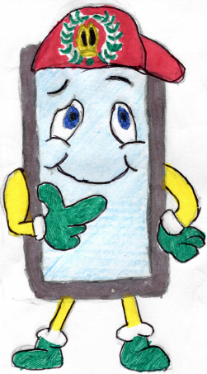**Get designing and help make St. Oswald’s C of E Primary School a safer place online!**

