**St. Oswald’s Church of England Primary School**

**Collective Worship Policy**



**RESPECT. RESILIENCE. KINDNESS**

**Vision**

Through valuing all individuals as children of God we believe in promoting an inclusive school community, rooted in mutual respect, understanding and kindness towards others. As God taught us;

Teach children how they should live, and they will remember it all their life; (Proverbs 22:6)

Our school’s vision is to nurture a resilient community where the love of learning thrives. We foster an

environment where every member feels supported in order to flourish, be empowered to overcome challenges, embrace growth and contribute positively to God’s world.

Life in all its fullness; (John 10:10)

**Monitoring and Evaluation**

The Head Teacher shall have oversight of this policy and ensure all staff follow procedures and that these are carried out.

The effectiveness of this policy shall be monitored during Governor’s meetings. This policy will be updated annually and any changes occurring during the year should be updated as soon as possible.

|  |  |  |
| --- | --- | --- |
| Date approved | Next Review Date | Signed by |
| September 2024 | September 2025 |  |

**Contents:**

1. Purpose
2. Audience
3. Christian Values
4. Curriculum intent
5. Implementation

Principles and practice

Objectives

Aims

1. Impact
2. Framework for Collective Worship
3. Professional Development
4. Monitoring and Evaluation
5. Special Educational Needs
6. Equal opportunities
7. Role of Collective Worship Leader
8. Evaluation of the Collective Worship Policy
9. **Purpose**

This policy is driven by the school’s vision, values and philosophy in relation to Collective Worship. It sets out to adhere to the relevant legislation and guidance for Collective Worship and reflects our vision for an inclusive community rooted in mutual respect. This policy explains what is meant by ‘collective worship’, why and when acts of worship take place. It also outlines the planning process and the elements of a meaningful and positive act of worship for the school; which is an aided Church of England Primary school.

The current law is determined by the Education Reform Act 1988, with some requirements deriving from the Education Regulations 1981. In summary the law says this:

* All pupils must attend a daily act of collective worship.
* It must be appropriate to the age, aptitude and family background of pupils.
* Responsibility lies with the head and governors, though the precise duties may vary according to the type of school.
* Details of arrangements for collective worship, including the policy, must be documented and available to the public.

1. **Audience**This document is intended for all adults in the school community. The policy is available on the school web site and staff shared drive.
2. **Christian Values**

St Oswald’s Church of England Primary school is a voluntary aided school and is founded on Christian values and beliefs. School collective worship is the recognition, affirmation and celebration of those values and beliefs, and is held to be of central importance within the school community.  
  
Collective worship celebrates and reaffirms our vision.

We believe that collective worship helps to foster, in pupils and staff, a sense of belonging to the school community. It provides an opportunity for spiritual development and personal understanding.

St Oswald’s is proud to be part of the UN Convention of the Rights of the Child, where every child is valued, cared for and developed to reach their aspirations.

St Oswald’s CE Primary is a ‘Rights Respecting’ School.

**This plan links to UNICEF Rights and Responsibility**

**Article 14: Freedom of thought, belief and religion**

*Every child has the right to think and believe what they want and to practice their religion, as long as they are not stopping other people from enjoying their rights. Governments must respect the rights of parents to give their children information about this right.*

**4. Curriculum intent**

Acts of worship will mainly link with the RE syllabus and Christian Values, however there are opportunities to include other areas such as Geography, History, Art, Music, Science, PSHE, Sustainability, UNICEF Rights and International links through the use of stories, poetry and visual images.

We believe it is important to help pupils as they transfer from one phase to the other and that worship provides pupils with an opportunity to gain support from the knowledge that they can rely on a loving God who can be with them as they journey through their school life. For these reasons Nursery pupils are included in acts of worship as soon as is appropriate. Year 6 pupils take part in the Diocesan Leaver’s Service at the Liverpool Anglican Cathedral.

**5. Implementation:  
 Principles and practice at our school**

These are our key principles in planning collective worship:

* All children will take part in Collective Worship every day.
* All members of staff will be given the opportunity to lead Collective Worship.
* All children will also be given the opportunity to take a lead and to participate.
* Members of appropriate organisations will be invited to share in Collective Worship.
* There will be opportunity to recognise the distinctiveness of the many faiths and world views shared in our community.
* The collective worship will include the singing of hymns and songs and opportunities are given, both to join in with and to listen to prayers.
* Time will also be provided for silence and reflection.
* The School will meet sometimes as a whole and sometimes in classes.

We see collective worship as an educational opportunity with clear objectives for spiritual development and wider SMSC awareness. We use this time to encourage pupils to:

* Show interest in, and a concern for, members of the school community
* Celebrate special occasions together
* Show concern for the daily happenings in school life, the local community, the wider world
* Share appreciation of worthwhile projects undertaken by groups within the school
* Explore and review the variety of values, attitudes, standards, manifested in religions and society
* Reflect on the way in which humankind has expressed the deepest spiritual feelings, through the creative and expressive arts, scientific discovery, religious practice, service to God and other people.

**Objectives**

* To ensure the relevant Education Acts are adhered to.
* To ensure the guidelines set out by the Governing body are adhered to.
* To uphold the message in the school’s Trust Deed and vision.
* To provide good quality and meaningful collective worship for pupils
* To provide staff with clear guidelines in their planning
* To provide explicit teaching in the school’s chosen Christian Values

**Aims of Collective Worship**Collective worship is different from Religious Education although it may reflect, highlight and reinforce aspects of the RE curriculum. The aims of Collective worship include:

* To provide an opportunity for the children to reflect upon God and to give him honour.
* To help children discover their place in the world.
* To highlight and nurture the spiritual dimension through experiencing worship.
* To provide children with a vocabulary of worship and an experience of a wide variety of worship forms, including symbols and imagery.
* To provide an opportunity to celebrate major, and some minor, Christian festivals.
* To heighten awareness of the ultimate questions / realities of life and to provide the opportunity to reflect upon these.
* To support the search for meaning.
* To enable children to appreciate their worth and value to God, and to the community, and to respect the integrity of all individuals as a child of God.
* To enable pupils to make effective use of silence in opportunities for reflection, contemplation, meditation and prayer, providing an opportunity for **personal reflection** on individual life or wider issues;
* To celebrate gifts, talents and achievements.
* To establish, explore, and reinforce the common Christian values of the school community and to learn, grow and celebrate together
* To learn about the United Nations’ Convention for children’s rights and explore their responses to the articles.
* To explore their own beliefs and understanding of God within a Christian framework.
* To offer opportunities to develop understanding of diverse faiths and cultures, so contributing to the promotion of **fundamental values**.
* To enable us to meet and engage with the **local community** through participants in assemblies;
* To respond to **topical or local issues** in a flexible and sensitive way;
* To provide chances for pupils and staff to **develop their own abilities** in preparing, presenting or evaluating assemblies.

**6. Impact**

*Community Links*

Parents are invitedwhen classes deliver their own worship based on the Christian Values they have been learning about for the year. The school holds Baptism services when the need arises. Confirmation classes are held in school and parents are encouraged to attend the Confirmation service at the cathedral. Parents can be invited, a few at a time, for special acts of worship in the school such as the ‘Sporties’ celebration.  
Due to a shortage of space in the school hall parents cannot be easily accommodated in acts of worship although they are encouraged to attend services; which are held in the Church. The school links, through worship, to the wider community in the supporting of the Shoe Box appeal, Shelter and UNICEF – visiting speakers attend the school to talk to pupils about these subjects during acts of worship.  
The school and church have a shared Harvest Festival Service each year that is held in the church and school on alternate years.

The whole school-visit the local shopping area every year for Carol singing to take the Christian message into the local community.

Music is seen as an integral part of Collective Worship and is used wherever possible~~.~~ The computer is managed by year 6 pupils who have the role of Worship monitors. The staff shared drive has a range of powerpoint presentations, songs and readings for use in worship.

There is a range of books of prayers and stories for staff to use in their planning, these are held in the World Faiths’ Room. There are artefacts available for use in the World Faiths’ Room as well as numerous online resources.

There is a wooden cross, candle, cloth and Bible for use in both the school hall these are set out before each act of worship by Year 6 pupils.

1. **Framework of Collective Worship**

* To foster a feeling of community and belonging in the school through a sharing of experiences and feelings.
* To develop personal relationships and to encourage social development.
* To provide an opportunity to empathise with the needs of others.
* To provide an opportunity for children to become acquainted with people from the local and wider community, particularly the local church.
* To encourage respect and care for God's creation by a positive attitude to both local and global environmental issues.
* To foster feelings such as awe, wonder, thankfulness, mystery and joy.
* To give memorable and enjoyable experiences.
* To provide an opportunity to bring before God in prayer personal needs and those of others.
* To share with participants some of the central teachings of the Christian faith at an appropriate level, and thereby give them the encouragement to explore their faith
* Collective worship is planned around six half termly themes. These are linked to the Anglican Festivals, Christian Values, SEAL and some themes from the Liverpool Diocesan RE Syllabus. Collective Worship may also reflect the festivals and celebrations of other faiths such as Sukkot, Eid, Diwali and Chinese New Year. We use the planning from ‘Roots and fruits’, ‘Simply collective worship’ and online sources such as assemblies.org, scripture union and the BBC to outline our worship focuses for each half term.

**Collective Worship is delivered by all teachers:**

* **Monday** – 20 minutes – morning - whole school worship is led by a member of the clergy or visiting speaker and member of SLT, in the school hall
* **Tuesday** – 20 minutes – morning –Class worship
* **Wednesday** – 20 minutes – morning~~.~~ Class worship
* **Thursday** – 20 minutes – morning - Class worship is based on picture news
* **Friday**- 30 minutes – afternoon – whole school worship and celebration of pupil achievements, led by Headteacher in the school hall.

Visiting speakers are met by the Headteacher who will inform them of the outline of worship and offer any support and guidance. The Headteacher, worship leader and clergy plan together for the combined school/ church services. The clergy and worship leader have regular discussions to plan weekly Monday worship and explore half term themes.

The children’s Worship Warriors club partake in planning and leading whole school worship twice a half term and in supporting Monday worship by performing a dramatised Bible stories, teaching a new song, puppet performances and leading prayers/ reflection.

The visuals of windows, mirrors and doors are what we use as a framework for each collective worship.

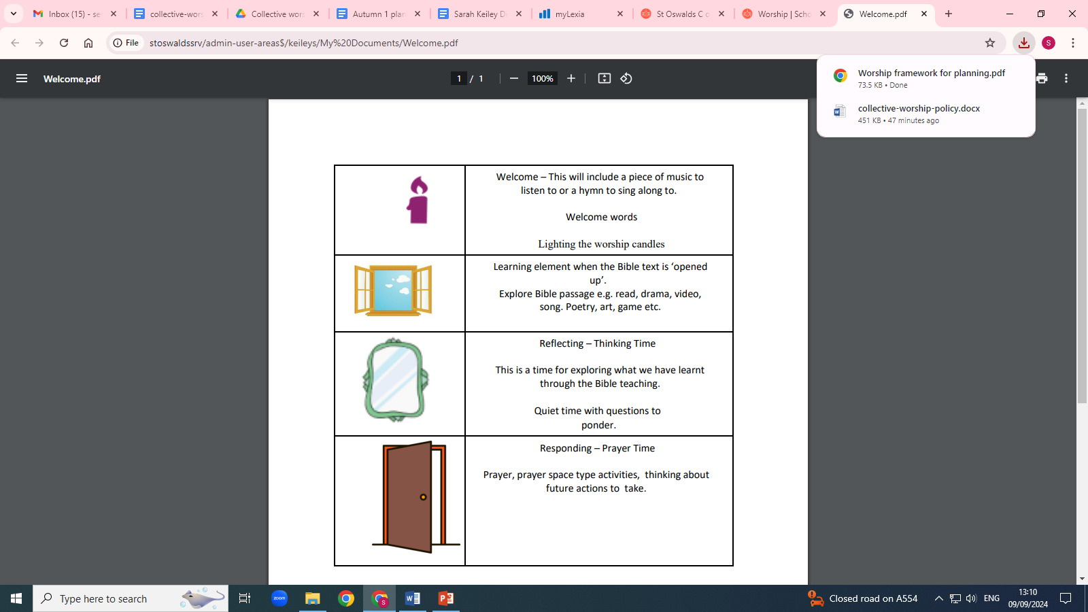

**8. Professional Development**This is addressed through the Staff Development policy, which reviews the institutions and individual members of staff’s professional development needs. There is also participation in any event / course, which is set up by Liverpool Diocesan Board of Education for church schools in the diocese. The Headteacher attends termly meetings for Liverpool Diocese aided schools when Collective Worship in schools is on the agenda.

**9. Monitoring and Evaluation**Monitoring and evaluation of collective worship is done in different ways:

* All children are encouraged to evaluate worship during the reflection time given at the end of whole school or class worship.
* The Worship warriors team conduct pupil voice once a half term.
* The collective worship lead and other members of the SLT may conduct a walkthrough during collective worship to speak to the children and evaluate the impact it is having.
* Pupil’s responses through questionnaires and School Council/Ethos Group representation are noted by the collective worship leader and Headteacher. The Head Teacher shall have oversight of this.
* The effectiveness of this policy shall be monitored during Governor’s meetings.

**10. Special Educational Needs**All pupils are to be included in Collective Worship regardless of any physical, learning or emotional needs they may have. Where necessary pupils will be supported or accompanied by additional staff to ensure a pupil’s inclusion and no pupil will be excluded from worship for additional teaching sessions. Collective worship shall include multi-sensory approaches where possible and the use of visuals to communicate and engage with learners who need support.

**11. Equal Opportunities**The school’s policy on Equal Opportunities is adhered to in acts of worship.  
All children have an entitlement to access to Collective worship. All children will have access to appropriate resources within the school. These will reflect a multi-cultural society, without stereotyping or discrimination. We are mindful of the need to promote the inclusion of all protected characteristics and all children will be given the opportunity to participate in all activities.

**Withdrawal of Pupils**

Parents have a statutory right to withdraw their children from collective worship. However, it is always good practice to arrange a meeting to discuss this with parents if a request emerges. There may be issues about a particular aspect of the programme which may be allayed after discussion. If the parent still feels they wish to withdraw their child, the request should be made in writing to the head teacher. This must be allowed by the school, which also needs to provide alternative activity and supervision for this pupil, although this must be at no additional cost to the school or local authority.

**12. Collective Worship Leader**

The leader for Collective Worship is Mrs Keiley who plans in consultation with the Headteacher and the clergy of St Oswald’s Church. The leader is responsible for the effective use of the budget, purchasing resources and identifying relevant professional development for staff. The plans are emailed to all staff. The Headteacher has responsibility to ensure implementation of the policy and the Governing Body is informed through the curriculum committee and at full Governor’s meetings.

**13. Evaluation of the Collective Worship Policy**Ministers, the Headteacher, and the worship leader undertake an annual review of the year’s Collective Worship. It also takes place by:

* the Annual audit to inform the school development plan,
* feedback from individual members of staff re-evaluation of medium-term plans,
* Team leaders/ performance management – individual targets for INSET
* Staff meeting evaluation time
* School Council/Ethos Group meetings.