*Worship Framework for Planning*

Before worship prepare by getting your resources ready, worship table out and music playing. Ensure that children who have a job to do know what they should be doing and are prepared.

Use the worship words powerpoint and the visuals (windows, mirrors, doors) below as a pattern/ structure for your collective worship.

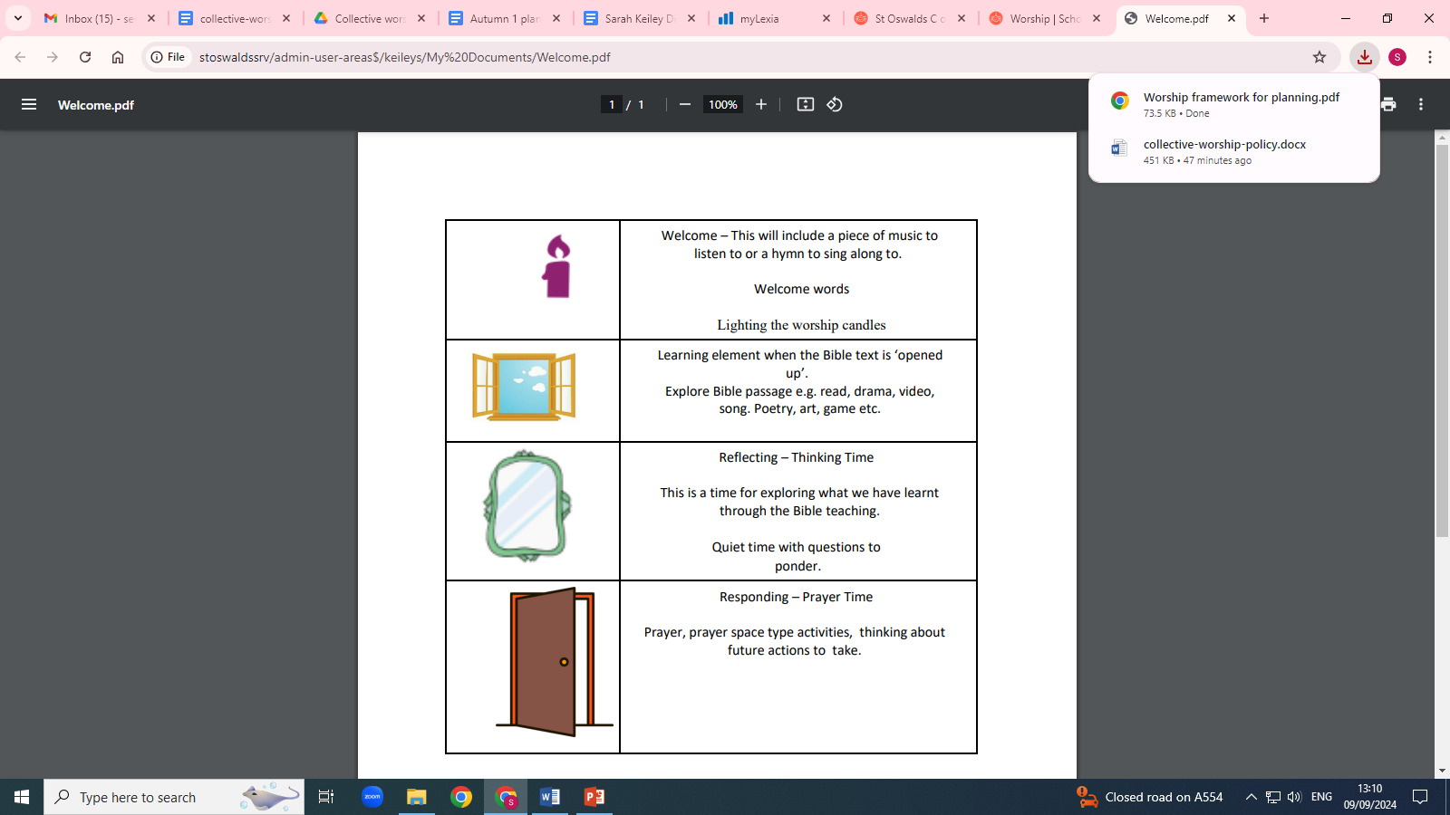

At the end of collective worship give children the opportunity to evaluate (this can be verbally or recorded on post it notes and kept in a box on your worship table.)