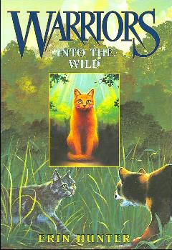
My Book Recommendation
By Erin
Warrior Cats: Into The Wild – Erin Hunter
I recommend Warrior cats: into the wild. Into the wild is about clans of cats who live in the forest: the brave and loyal Thunderclan; the swift and arrogant Windclan; the swimming, fish-eating Riverclan; and the stealthy and proud Shadowclan. When Shadowclan’s evil leader threatens all the clans way of living, Thunderclan is under constant threat. Peace is shattering and as war rages in the forest, a ginger housecat named Rusty wonders into the wild, and he might be the bravest cat of them all. This book is the first of a huge and famous series; lots of people make warrior cats fan art and animations. It has a humungous 5 series, the last series will be series 6: The Broken Code. The first series is from Rusty’s point of view, but all the other series have loads more interesting heroes and heroines. There are also a lot of strong female characters.
I recommend this book for the age group 11 to 15, since there is blood and gore. If you don’t like fights, verbal or physical, then this is not the book for you. Lots of deaths are very gory, like the death of the first series' main villain. There is also romance in the later books of the series, so if you are planning to read all the warrior cat books you have been warned.
I learned a lot from this book; it’s the book that got me into reading. Most of the skills I learned about writing stories were either from this book series or wings of fire (another amazing read; I really recommend it). If you want to learn writing skills while having fun; if you are ok with gore, and you like romance than this book is for you. It’s a great book and I hope that you read it.
I would rate this book:

