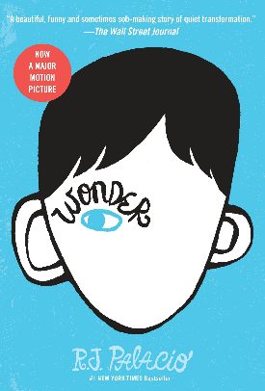
My Book Recommendation
By Keisha
Wonder – R J Palacio
August Pullman is a ten-year-old boy suffering from severe birth defects, including mandibulo-facial dysostosis and a cleft palate, which have left him disfigured. His parents decide to enroll him at Beecher Prep after years of homeschooling him. During a tour of the school, August meets Jack, Julian, and Charlotte. Jack is nice to him, and August believes he has found a friend.

On Halloween, August overhears a conversation between Jack and Julian in which Jack says he's only nice to August because Mr. Tushman, the school principal, asked him to be. Upset, August stops talking to Jack, who feels guilty about being mean. He really does want to be friends with August.

One day, Jack punches Julian for saying mean things about August. Mr. Tushman mediates between the boys, giving them winter break to cool off. After break, Charlotte warns Jack that Julian is turning the entire class against him, convincing people that Jack is unstable. Jack starts eating lunch with August and his friend Summer.

At a wilderness retreat, August is attacked by a group of seventh graders. Henry, Amos, and Miles, Julian's best friends, help August and Jack escape. Public opinion swings in favor of August and Jack, and Julian is ostracized. In the end, August wins the Henry Ward Beecher medal, which is reserved for an "exemplary" student. August is amazed that he survived fifth grade. His friends and family make him feel like a regular kid.

I recommend this book to students over 8. It has strong messages all the way through about not judging people on their appearance and really makes you think about real life and situations.

Because of this I rate this book:

