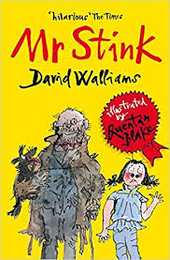
My Book Recommendation
By Leila
Mr Stink by David Wallliams

This book is about a tramp (homeless person) called Mr Stink and a girl, whose name is Chole. Chole meets the tramp in the park and decides to help him by giving him food and drinks. But one day she secretly brings him home to stay in the shed at the end of her garden. This act of kindness leads to trouble for Chole and her family but in the end, it all turns out ok!
Which part did you like the best?
I like the part when Chloe sees a photo of a young woman and man in the driveway of a mansion with a lovely Rolls Royce because it might be a special memory for him and when she askes Mr Stink what it was, he said it was nothing and I liked how Chloe figured it out in a creative way.
Who should read this book and why?
I think that this book is good for 8+ because some of the words in it are quite advanced; it’s a very relatable story that children and adults can read and enjoy together
What does it teach you? New words, new way of thinking, moral of the story?
The story teaches people about being kind and loving to other people who might seem odd like Mr Stink but that doesn’t mean you can be nasty to them. The key vocabulary that I like, and I might use in my stories, are:
- Immaculate=flawless
- Sentimental=emotions and feelings
- Waz=wee
- Sorrowfully=sadly
- Flustered=excited, confused or nervous
- Anticipation=hope or expectation
- Controversial=decision
- Confectionary=candy
The moral of the story is to be nice to people even if you don’t know who they are.
I would rate this book:

