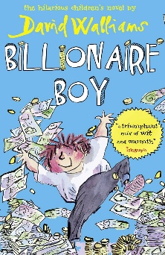
My Book Recommendation
By Kimaya
Billionaire Boy by David Wallliams

Billionaire Boy is all about Joe Spud who happens to be a billionaire's son. Mr. Spud was an ordinary man when he created Bumfresh products for money.
Joe Spud happens to get everything he wants but there is only one thing he desperately needs and that is a friend. When he gets bullied at an expensive school, he then transfers to a local school. Sadly, he hides his richness as he is afraid people might call him a spoilt brat and be bullied. In the local school Joe makes friends with a boy called Bob which is a big delight to Joe.
Mr Spud ends up losing all of his money because the products are making everyone’s bottoms turn purple. The story concludes with happiness as Mr Spud marries Joe’s best friend’s mum. The moral is that money isn’t everything and that family and happiness in life are far more important.
I would recommend this book to ages 6+ as it teaches you that you shouldn’t buy friendship because before you know it those people you made friends with won’t be your friends anymore. Joe Spud is a good character, but he happens to have way more things than a twelve-year-old should have like his own bowling alley! Seriously! Don't you think that is too much for a twelve-year-old? The other reason I would recommend this book because it is funny , interesting and engaging! If you like humorous books than this is a book for you.
A good idea that you can use in your writing is a person bribing someone or a person trying to hide something as they our afraid they might get teased.

I would rate this book:

