The Big Garden Birdwatch.
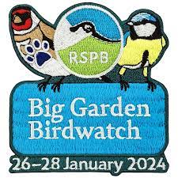
Why not take part in a real-life scientific study into UK bird numbers in our area.? This weekend it’s the RSPBs Big Garden Bird watch.
All you need to do is set aside an hour of your time and record the number and type of birds you see land. This can be in your back garden, in the local park or even from your window.
Details of how to take part are below.
Good luck!
https://www.rspb.org.uk/whats-happening/big-garden-birdwatch

