27th February | Peace | 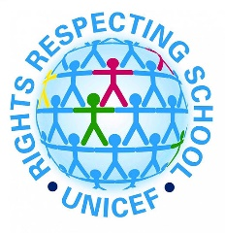 | Article 5: Governments must respect the rights and responsibilities of parents and carers to provide guidance and direction to their child as they grow up, so that they fully enjoy their rights. This must be done sin a way that recognises the child’s increasing capacity to make their own choices.
6th March | Perseverance |  | Article 13: Every child has the right to meet with other children and to join groups and organisations, as long as this does not stop other people from enjoying their rights.
13th March | Friendship |  | Article 27: Every child has the right to a standard of living that is good enough to meet their physical, social and mental needs. Governments must help families who cannot afford to provide this.
20th March | Thankfulness |  | Article 3: The best interests of the child must be a top priority in all things that affect children.
27th March | Hope |  | Article 31: Every child has the right to relax, play and take part in a wide range of cultural and artistic activities.

